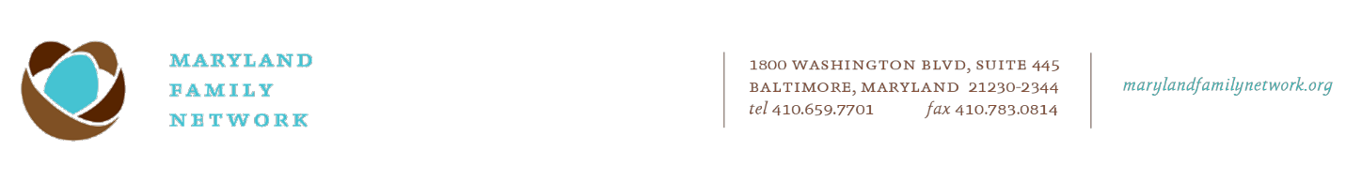

May 6, 2024

Dear Prospective Applicant:

Maryland Family Network, the state-wide intermediary overseeing the network of Patty Center - Family Support Services, on behalf of its public and private funders, solicits proposals from organizations to operate a Family Support in Maryland. This funding opportunity is available as part of the BluePrint for Maryland’s Future. Funding for this opportunity is provided by pass-through State Funds from the Maryland State Department of Education.

Grant applications must be received by 5 pm EST on 6/14/2024. Email proposal and supporting documents to [FSC_RFP_application@marylandfamilynetwork.org](mailto:FSC_RFP_application@marylandfamilynetwork.org).

Agencies intending to submit a proposal are asked to complete a simple online form which will serve as a Letter of Intent to Apply by 5:00 pm EST 5/29/2024. Complete Letter of Intent to Apply here: <https://www.surveymonkey.com/r/K7P6KNG>

A Pre-Proposal Virtual Meeting will be held on Monday, May 20, 2024, at 12:30 pm EST. Please use this link to attend: <https://us02web.zoom.us/j/85773835334?pwd=blR0OWZjS1NrTkVVU295SmpKc1BpQT09>

You are encouraged to share this information with anyone interested in operating a Patty Center - Family Support Services in the state of Maryland.

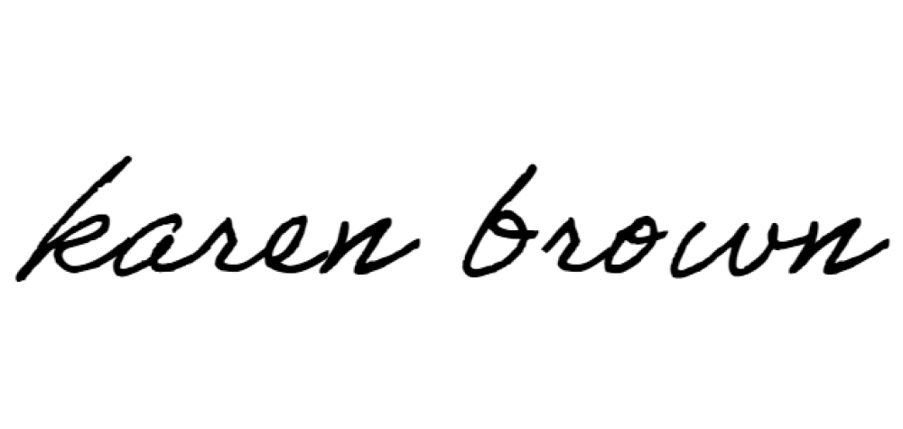Sincerely,

Karen Brown

Family Support Center Network Director